**Moderate to Severe Evaluation**

Sample_id : **PT3AUY(Dog)**

Link:<https://release.animalbiome.com/pet/assessment/report/appendix/c4514aa5-b76d-4dbc-9969-0a29b4d52349>

Cats and dogs:

Any two of the following:

(

High Red Flag Megamonas OR (failed)

High Red Flag Sutterella OR (failed)

High Red Flag Collinsella OR (failed)

Low Red Flag Bacteroides OR (**passed**)

Low Red Flag Blautia (failed)

);

OR

Dogs:

8 or more yellow flags (failed)

OR 8 or more red flags (**passed**)

High red megamonas,suttrella and collinsella failed.

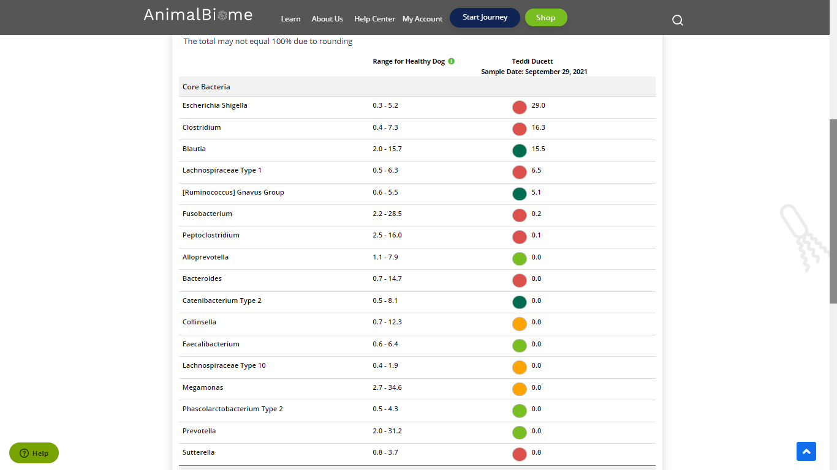

Low group evaluation:

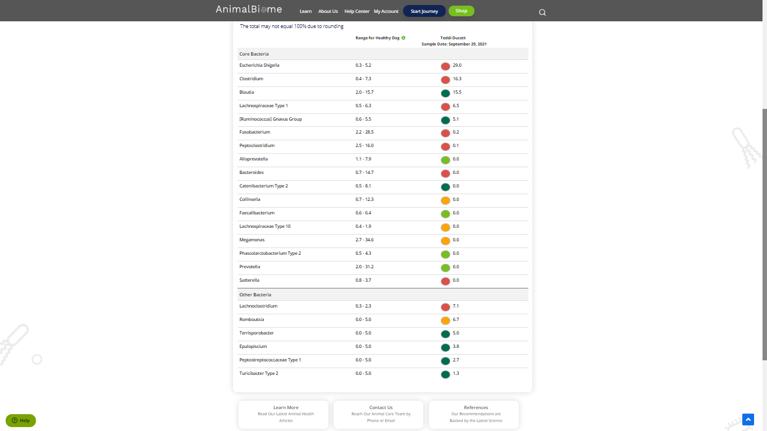

low red blautia : failed.

Low red bacteroides : passed (only one condition satisfied ) in the primary group.

Total yellow flags : 4

Red flags : 8

The result : **False False True**

Moderate to severe results:Pass

Expected result : **Moderate to severe**

Achieved result : **passed**.

